CMPT 743 - Project Proposal

Optimized 3D Rendering with Gaussian Splatting

Amanda Shum, Amogh Das, Utsav Anantbhat
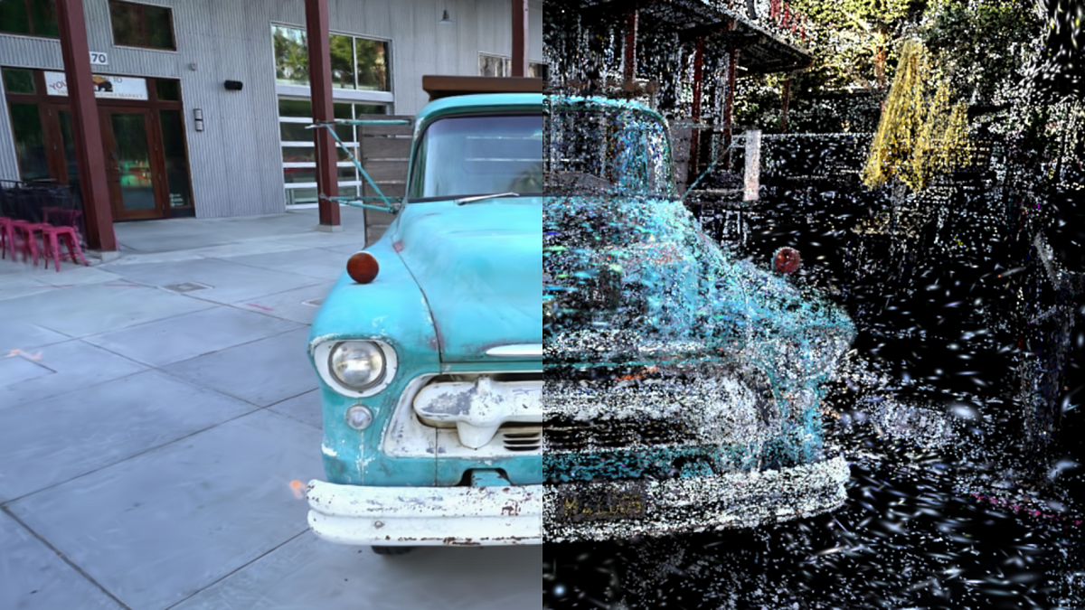

Introduction

There have been many advances in text-to-3D generation that allow for the creation of highly detailed 3D assets from text descriptions. Systems such as Fantasia3D are able to create rich, editable geometry in the form of 3D meshes and textures. This is done by leveraging 2D diffusion models to guide the optimization of said meshes. However, such approaches suffer from slow optimization, limited real-time feedback, and inconsistencies with multi-view appearance.

Parallely, Gaussian Splatting is an efficient scene representation model that enables real-time rendering with high visual fidelity. This is achieved by rasterizing anisotropic Gaussian primitives rather than relying on volumetric ray marching, which is rather costly. While Gaussian Splatting excels at fast and consistent multi-view rendering, it lacks explicit surface representations, thus making it unsuitable for geometry editing.

This project proposes a hybrid 3D generation framework that combines Fantasia3D’s mesh-based generation with Gaussian Splatting’s real-time rendering capabilities. Our goal is to reduce, if not eliminate, the weaknesses of each of the approaches in isolation. Theoretically, this can be achieved by anchoring the Gaussian splats to Fantasia3D-generated geometry and jointly refining appearance under diffusion guidance.

Why Choose This Project?
This project will help address a practical problem in the field of visual computing. Current text-to-3D systems are typically optimized for editability and structural consistency or rendering speed and appearance, not both.

Existing 3D reconstruction methods face a trade-off between geometric accuracy and semantic completeness. Data-driven approaches such as Gaussian Splatting produce realistic, accurate geometry but are weak to limited views or occlusions, resulting in incomplete reconstructions. Additionally, methods such as Gaussian Splatting require large amounts of multi-view data to produce accurate geometry. Fantasia3D can generate semantically plausible geometry from limited input, but there are no constraints by real-world objects, which can lead to inconsistencies.

We want to address the limitations and weaknesses of Gaussian splatting and Fantasia-3D by combining the realistic geometric reconstruction from Gaussian splatting and utilizing semantic prior knowledge from Fantasia3D. By unifying their complementary strengths, we hope to gain the best of both worlds in one system. This system can then be applied to various applications such as AR/VR, 3D asset prototyping, and real-time 3D model generation.

What We Hope to Achieve
The primary objective of this project is to design and evaluate a hybrid 3D representation that jointly leverages semantic priors from text-to-3D diffusion models and the rendering efficiency and multi-view consistency of Gaussian Splatting.

Specifically, we aim to:

1. Develop a hybrid representation
Anchor Gaussian splats to a mesh-based geometry generated using Fantasia3D. The mesh will act as an explicit structural prior, while Gaussian splats will model view-dependent appearance and fine-grained details.

2. Jointly optimize geometry and appearance
Investigate a training pipeline where:
- Fantasia3D provides an initial coarse geometry from text prompts
- Gaussian splats are initialized around the mesh surface
- Appearance is refined under diffusion guidance while enforcing multi-view photometric consistency

3. Improve generalization to incomplete or sparse views
Evaluate whether semantic priors from diffusion models enable better reconstruction of occluded or missing regions compared to Gaussian Splatting alone.

4. Enable real-time rendering with editable geometry
Demonstrate that the proposed approach supports real-time or near real-time rendering while retaining explicit surface representations suitable for downstream editing tasks.

5. Analyze trade-offs between realism, consistency, and efficiency
Quantitatively and qualitatively compare the hybrid approach against:
- Pure Gaussian Splatting
- Pure text-to-3D mesh optimization
using metrics such as rendering speed, multi-view consistency, and perceptual realism.

Tentative Methodology
We propose a 3-phase implementation strategy where we would begin by reproducing the pipeline from Gaussian Splatting and running Fantasia3D to generate some initial mesh geometry.
In the first phase, we will reproduce results from both Gaussian Splatting and Fantasia3D to create baselines.
This will involve running Fantasia3D to generate coarse 3D meshes from text prompts and rendering the meshes. Then, we will reproduce the results from the Gaussian Splatting pipeline to create a baseline for rendering performance.
To construct the hybrid system, we will attempt to combine the mesh geometry from Fantasia3D with Gaussian splats. For this method, we will use the coarse meshes generated by Fantasia3D and sample points along the mesh surface. Then we can initialize Gaussian splats at these sampled locations.
The mesh will provide structural and semantic geometry, and the Gaussian splats will capture fine details, shading, and view appearance.

Finally, we will attempt to optimize the hybrid system to improve visual quality and consistency.
L = L_{image} + 𝝀L_{appearance}
Where L_{image} ensures visual consistency, L_{appearance} ensures a semantically plausible appearance, and 𝝀 balances the two objectives.

The final system will produce a hybrid 3D representation consisting of a mesh for structural editing and semantic geometry and Gaussian splats for high-quality appearance.

References

Fantasia3D: Disentangling geometry and appearance for high-quality. Fantasia3D: Disentangling Geometry and Appearance for High-quality Text-to-3D Content Creation. (n.d.). https://fantasia3d.github.io/assets/Fantasia3D.pdf
Kerbl, B., Kopanas, G., Leimkühler, T., & Drettakis, G. (2023, August 8). 3d Gaussian splatting for real-time radiance field rendering. arXiv.org. https://arxiv.org/abs/2308.04079
Nvidia, Bala, M., Cui, Y., Ding, Y., Ge, Y., Hao, Z., Hasselgren, J., Huffman, J., Jin, J., Lewis, J. P., Li, Z., Lin, C.-H., Lin, Y.-C., Lin, T.-Y., Liu, M.-Y., Luo, A., Ma, Q., Munkberg, J., Shi, S., … Zhang, Q. (2024, November 11). Edify 3D: Scalable high-quality 3D asset generation. arXiv.org. https://arxiv.org/abs/2411.07135v1
Soumyadip. (2025, July 27). 3D Gaussian Splatting Introduction – Paper Explanation & Training on Custom Datasets with NeRF Studio Gsplats. https://learnopencv.com/3d-gaussian-splatting/
Wang, J., Chen, M., Karaev, N., Vedaldi, A., Rupprecht, C., & Novotny, D. (2025, March 14). VGGT: Visual geometry grounded transformer. arXiv.org. https://arxiv.org/abs/2503.11651

